1. Context
   1. What is context and how can it help in developing pervasive application

**Answer :**

Context is any information that can be used to characterize the situation of an entity. An entity is a person, place, or object that is considered relevant to the interaction between a user and an application, including the user and applications themselves. In the pervasive application or in this case context-aware application, these entities are any relevant to the interaction between the user and application. Context-aware applications use context to provide task-relevant information and/or services to a user.

* 1. You are asked to develop context aware application for education. Describe your design

**Answer :**

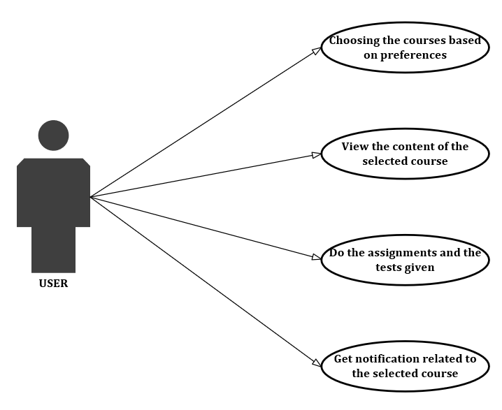

For example, I want to develop an online course application. The product which I offer to the user, or the subscribers is based on their preferences and interests. So, it’s related to the User context. The subscribers or the clients could choose their own courses which they want. Then, the clients can view the materials of the selected courses and learn it. The application provides assignment and test features to improve and test the client’s ability to understand the materials. The clients will also get some notifications on their devices which related to the courses which they selected before, high rated courses, latest course trends, etc.

1. Fingerprint method

Given the fingerprint below, recorded signal strength in dBm (decibel milliwatt), 6 rooms from 2 access point (AP1, AP2).

If someone record signal of -55 dBm (AP1) and -60 dBm (AP2), how do you calculate his location?

|  |  |
| --- | --- |
| **Room 1**  AP1: - 40 dBm  AP2: - 70 dBm | **Room 2**  AP1: - 50 dBm  AP2: - 60 dBm |
| **Room 3**  AP1: - 50 dBm  AP2: - 60 dBm | **Room 4**  AP1: - 65 dBm  AP2: - 50 dBm |
| **Room 5**  AP1: - 70 dBm  AP2: - 50 dBm | **Room 6**  AP1: - 80 dBm  AP2: - 40 dBm |

**Answer :**

The online location based on receive signal strength could be calculated using Euclidean distance.

Given :

Recorded signal :

AP1 : -55 dBm

AP2 : -60 dBm

Euclidean distance formula :

$$d= \sqrt{{(X_{1}- X_{2})}^{2}+ {(Y_{1}- Y_{2})}^{2}}$$

In this case :

d : Euclidean distance

X1 : Fingerprint value for AP1

X2 : Recorded signal on AP1

Y1 : Fingerprint value for AP2

Y2 : Recorded signal on AP2

In Room 1 :

|  |  |
| --- | --- |
| X1 : -40 dBm | X2 : -55 dBm |
| Y1 : -70 dBm | Y2 : -60 dBm |

dBm

Based on the similar calculation in Room 1, the Euclidean distance for Room 2 until Room 6 are :

|  |  |
| --- | --- |
| **Room 1**  18,303 dBm | **Room 2**  5 dBm |
| **Room 3**  5 dBm | **Room 4**  14,142 dBm |
| **Room 5**  18,303 dBm | **Room 6**  32,015 dBm |

The minimum value of Euclidean distance in Room 1 until Room 6 is 5 dBm. It’s located in Room 2 and Room 3.

1. Explain TOA, TDOA and AOA method and give example what localization technology utilize it.

**Answer :**

The time of arrival (TOA) and time difference of arrival (TDOA) methods rely on the propagation time of a signal traveling from the transmitter to the receiver.

* In the **TOA** method, the one way propagation time is determined and the distance between reference node and transmitter is estimated and requires accurate time synchronization between the target node and the reference nodes clocks. Technologies which utilized this method are Ultra Wide-Band (UWB), microwave, and cellular network localization.
* The **TDOA** method depends on processing the time difference of the multiple signals that is generated from several reference nodes when arrived to a receiver device. By this way, the receiver device can measure its position. Each TDOA determines that the receiver device should lie on a hyperbolic with constant range differences between the two transmitting reference nodes. Two pairs of reference nodes are required to find the position location of a receiver device in 2D and three pairs of reference nodes are needed in case of 3D. TDOA could detect the position of illegal radio transmission. Technologies which utilized this method are Wi-Fi, Bluetooth, Wireless Sensor Network (WSN), ultrasound, magnetic, visible light, and Pedestrian Dead Reckoning (PDR)
* Angle of arrival (**AOA**) is a network-based positioning location method that measures the time take by radio signals to arrive at several points. AOA method uses an antenna containing a multiple element array in which the exact location of each AOA element is known precisely. The AOA method requires a minimum of two reference stations with directional antennas with narrow beam widths. Technologies which utilized this method are UWB, microwave, and cellular network localization.

1. How IP version 6 can help the proliferation of pervasive computing application?

**Answer :**

Ubiquitous connectivity and control are fundamental elements of the Internet of Things (IoT) value proposition. The goals of IPv6 were to support scalability, security, and multimedia transmissions.

IPv6 provides real-time information by enabling faster communication by eliminating significant administrative overhead that exists in the IPv4, faster packet processing through elimination of IP checksums, faster routing through elimination of multi-layered routing and shorter routing tables and bandwidth efficiency through multi-casting in place of broadcasting, to name a few.

Then, IPv6 makes the process and transport any information more secure with IPsec support which provides end-to-end confidentiality, authentication and data integrity. From the point where the data originates to its point of destination the data is secured and encrypted thus reducing cyber attacks where data can be hacked during transit.

The last one is IPv6 provides user adaption. With the majority of devices and things that users are surrounded with, the key component of user adoption is ‘ease of setup’ and ‘ease of use’. Users now expect devices to come without extensive product manuals and work upon first power-on as soon as they remove it from the box. IPv6 offers this experience through static IP addresses for each device or M2M connection, which eliminates the need for extensive manual configuration to connect new digital devices or things to a network. IPv6 connections can be pre-configured for first-time use, thus enabling and simplifying IoT.